PREPARE Group Meeting
19th June 2020, Skype

MINUTES of the meeting

Participants: Sybille Braunegg, David Camocho, Cristina Rocha, Oihana Hernandez, Aida Szilagyi, Peter Glavic, Stig Hirsbak, Thomas Schonfelder, Vladimir , Pavel Rudzika, Vladimir Dobs, Fabbio Iannone
The Meeting between 12:00 am – 13;30 pm and was led by the Secretariat. The main topics discussed:

1. National highlights and COVID 19 stress, All members
2. PREPARE Annual Report 2019 – 2020, Aida
3. Project situation – what is new? All members
4. Website updates, Aida
5. Next Prepare Meeting

- National Highlights

Denmark, Stig – provided news about the preparations in the country for the new Green Deal and circular economy polices and initiatives in the country.
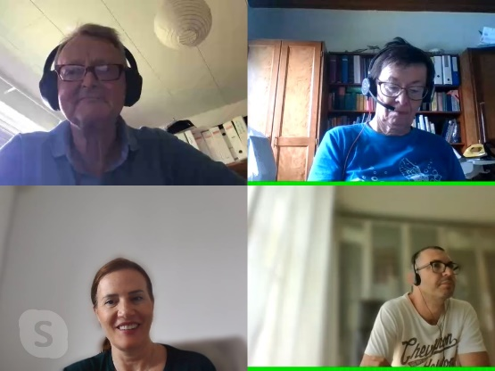
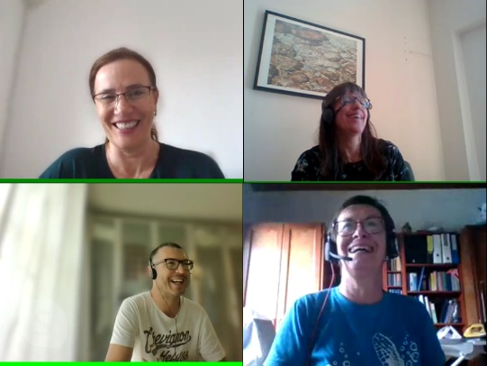
Portugal, Cristina & David – talked about COVID situation in Portugal, the Katche-e project final opportunities, MOOC and tools offered to the public now, the Circular Start and de-Construction project starting soon. Cristina also mentioned new opportunities related to the European Green Deal Call to be published in September and the topic of interest related to “Demonstration of systemic solutions for territorial development of the circular economy. She promised to circulate the documents and invited the members to express their interest in the call
Spain, Oihana talked about COVID situation in Spain and presented the new Erasmus Plus Circular Start project, comprising also partners from Prepare.
Austria, Sybille talked about the COVID situation in Austria and StadtLabor activities in helping cities to integrate innovative solutions
Romania, Aida – talked about COVID situation in Romania, the new educational platform launched by EduZWaCE, the situation in automotive industry and the latest policies on Deposit Return Scheme on the way to be implemented in the country.
Czech Republic, Vladimir and Pavel - provided updates about Coronavirus situation and their projects, happy to see Vladimir is back, we missed him!
Slovenia, Peter – has updated as about the new initiative of Copernicus Alliance COST Action proposal- Assuring Transformative Learning for Sustainable Development in Higher Education (ASTRALS). ASTRALS is an initiative of the COPERNICUS Alliance that seeks to build and expand a pan-European, multidisciplinary and multi-stakeholder network to promote transformative sustainability learning in higher education while assuring quality through clear, transferable indicators.
Italy, Fabio, we welcomed a new participant in Prepare meetings! Fabio works as Ph.D Researcher in Sustainability Management for Sant'Anna School of Advanced Studies, and he interested to collaborate with Prepare members having a particular interest in the next Horizon2020 and he promised to keep as updated with the news related to calls.

- Prepare Annual Report 2020 and other issues

Aida provided the status of the work performed by the Secretariat between 2019 – 2020 and presented the annual report: activities performed by the Secretariat, membership and financial situation, project status, meetings, etc. Discussion about the next Prepare meeting advanced the idea of having the project in connection with the last EduZWaCE meeting in September in Prague.
Inactive members have been addressed and asked if they still want to receive emails from Prepare Secretariat but not to many answers have bene received. The Newsletter will be released based on the information collected during the skype meeting about the initiatives in the countries and new projects. The Secretariat will continue to ask the partners to send news every four months.
The newsletter will be released on LinkedIn and FB.
Aida launched a new invitation for more reactions to the Prepare Facebook page.

- Project proposals in 2020

Aida reported on projects proposals submitted in 2020 on Erasmus, that included other Prepare members, for the first time Santa Anna Institute and Vienna Technical University participated at the invitation of the Prepare Secretariat.
Virtual Factory Erasmus+, Strategic partnerships in the field of educ., applied on 29.3.2020, currently under evaluation, partners STHEV, UM, NCSPC, NCPC Serbia, coordinated by Rebecca
Smart Education for Corporate Sustainability Reporting, SECuRE, Erasmus+, Strategic partnerships in the field of education, applied on 29.3.2020, currently under evaluation, partners NCSPC, UM, ERGO, Prospektiker, WTU, coordinated by Aida

- PREPARE communication and website

Aida presented the new website and its features. The website has been finalised, all member accounts have been created and the members’ contact included in the website and accounts for each paying member. The list with users and passwords have been provided together with the warm invitation of using the forum for exchanging ideas and creating new projects.

- Prepare Networking

Definitely it was a successful meeting! The people were happy to see each other, even if it was virtual exchange ideas and discuss. This is what Prepare stands for! We are looking forward to meet you in person in Prague, in the autumn time!
The PREPARE Secretariat

