PREPARE Core Meeting
&
TREO Meeting
22 – 23 June 2015 – Prague, Czech Republic

Agenda

DAY 1 – Monday, 22 June 2015

Venue: Enviros (see below)
TREO Meeting
9:00–9:30 |  | Coffee and Welcome
9:30–11:00 |  | Marketplace – future projects |  | All
11:00–11:30 |  | Coffee Break
11:30–13:00 |  | National highlights |  | All
13:00 – 14:00 |  | Lunch
14:00–14:15 |  | Welcome and opening introduction |  | Pavel Ruzicka  Peter Glavic
14.15–15:15 |  | Status of Reports  - Buildings  - Mobility  - Food  - Energy  - Interim report |  | Sebastian Friedberger  Oihana Hernaez  Stig Hirsbak  Peter Glavic  Pavel Ruzicka
15:15–15:45 |  | Coffee break
15.45–16.00 |  | Final report  Reporting obligations after project end |  | Stig Horsbak
16:00–17:00 |  | Global CP&SC Conference and PREPARE |  | Peter Glavic
19:00 |  | Dinner

Lunches and dinner are to be paid by participants, coffee will be kindly granted by Enviros.

DAY 2 – Tuesday, 23 June 2015

Venue: Enviros (see below)
PREPARE Marketplace and Core Group meeting
9:30–10:00 |  | Welcome and introduction |  | Peter Glavic / Pavel Ruzicka  MoE representative (tbc)
10:00 –10:30 |  | Host country presentation |  | Pavel Ruzicka
10:30–10:45 |  | Coffee Break
10:45 –13:00 |  | Circular Economy-related presentations  - EC or UNEP presentation (tbc)  - Czech representative – Ministry of Industry (tbc)  - Michele Rosano, J. of Recycling
13:0 |  | Closing
13:00–14:00 |  | Lunch

Contacts:

PREPARE Secretariat EMPRESS
Mr. Peter Glavic Mr. Pavel Ruzicka
Secretary General EMPRESS/Enviros
E-mail: peter.glavic@um.si E-mail: pruzicka@enviros.cz

Venue

The meetings will take place at: ENVIROS, s.r.o., Na Rovnosti 1, Prague 3
The bus No. 133 from metro Florenc or the bus No 124, 297 from metro Zelivskeho.

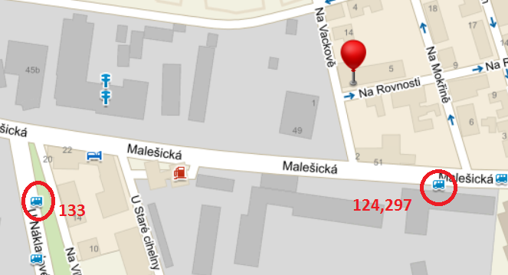

Hotels:

The possibility we have is in Hotel Penta (http://www.pentahotels.com/en/hotels/phpra-prague/everything) The address: Pentahotel Prague, Sokolovská 112/56, Prague 8

The prices (after all reductions) if You mention “PREPARE” during the booking:
- the accommodation per person and night 90 €
How to get there  From the airport:  Take bus 100 to metro station Zlicin (final stop). Take metro there (line B, yellow) and get off at station Krizikova.  Approx. 50 min  From train station Hlavni nadrazi (Main station):  Take metro line C (red) direction Letnany and get off at station Florenc (one station).  Approx. 5 min | 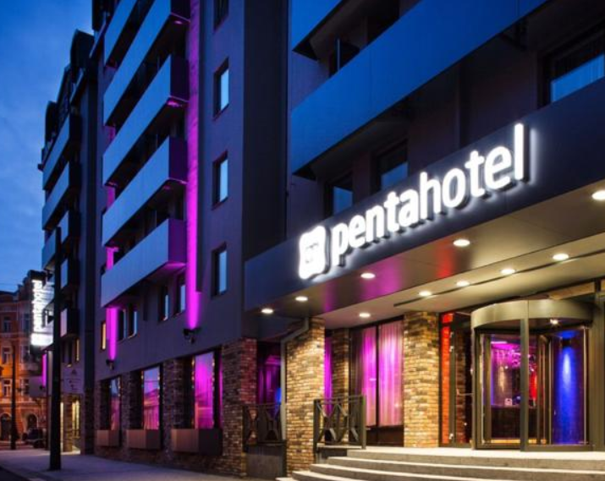

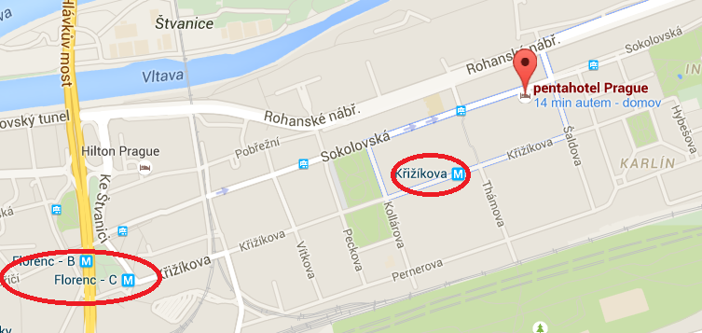

If you arrive by car, you can park in the hotel’s backyard. The price is not included in a room price; the hotel charges 500 CZK/day (approx. 18 €/d).

The other option is the Hotel Courtyard Prague Flora, but without any price reduction.
The address is Lucemburska Street 46, Prague 3, Czech Republic
URL: http://www.marriott.com/hotels/travel/prgcy-courtyard-prague-flora/

How to get there  From the airport:  Take bus 119 to metro station Nadrazi Veleslavin (final stop). Take metro there (line A, green) and get off at station Flora.  Approx. 45 min  From train station Hlavni nadrazi (Main station):  Take tram 5 (direction Ústřední dílny DP) and get off at station Flora.  Approx. 10 min | 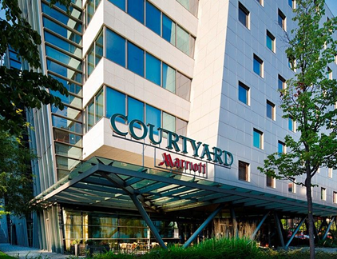

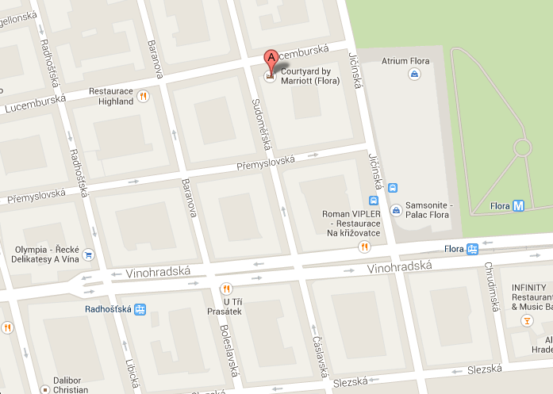

If you arrive by car, you can use hotel’s garage. The price is 500 CZK/day (approx. 18 €/d).

3-star hotels:

Hotel Atlantic

Na Poříčí 9, 110 00 Prague 1

URL: http://www.hotel-atlantic.cz

B&B Hotel Prague-City

Prvního pluku 29, 186 00 Prague 8

URL: http://www.hotelbb.cz/cs/prague-city

Both hotels are situated close to Florenc area, near to which the Hotel Penta is located.

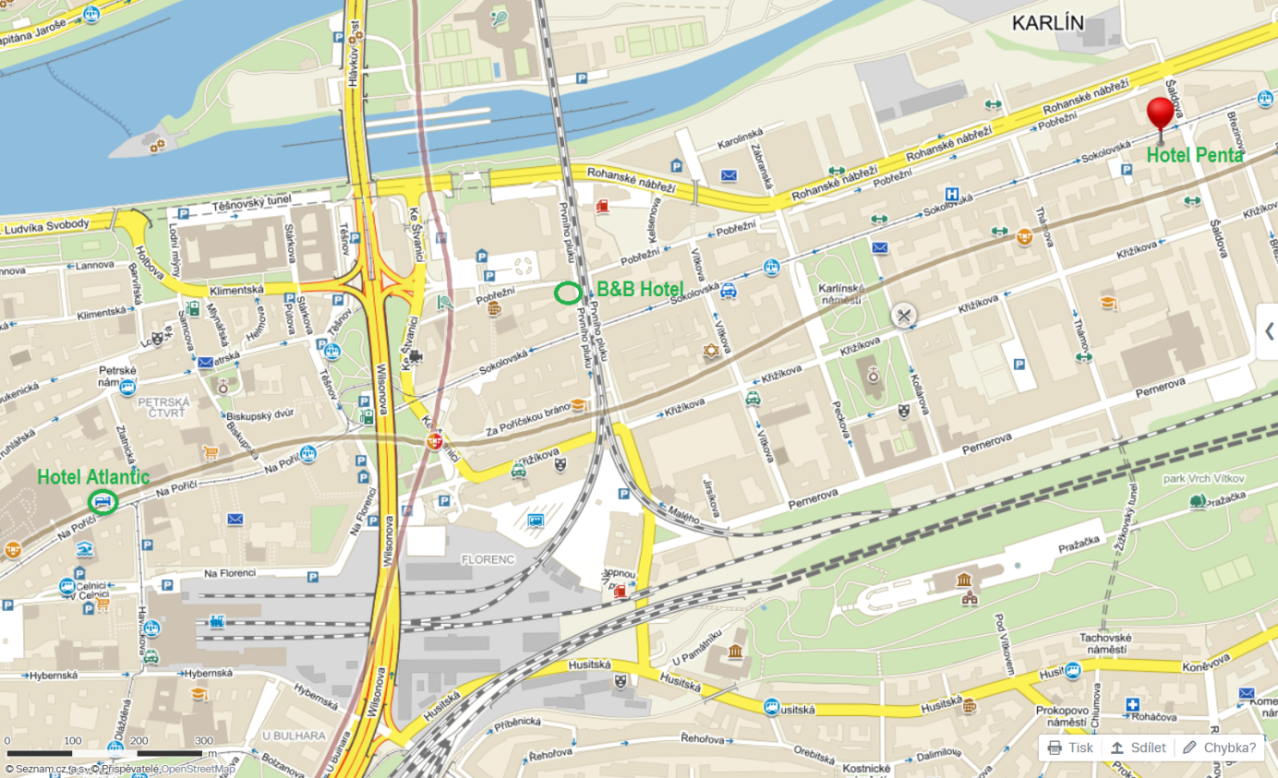

Hotel Populus  U staré cihelny 2182/11, 130 00 Prague 3  URL: http://www.hotelpopulus.cz  The hotel is situated close to Enviros office. | 