PREPARE Core Group Meeting
21 – 22 March 2013 – Lisboa, Portugal

Time: 21/03/2013, 9:00 – 22/03/2013, 13:00

Venue and accommodation:
Lisboa, York House Hotel****: http://www.yorkhouselisboa.com/pt/
Rua das Janelas Verdes, 32, 1200 - 691 Lisboa – Portugal
Ph: +351 21 396 24 35 | Fax: +351 21 397 27 93

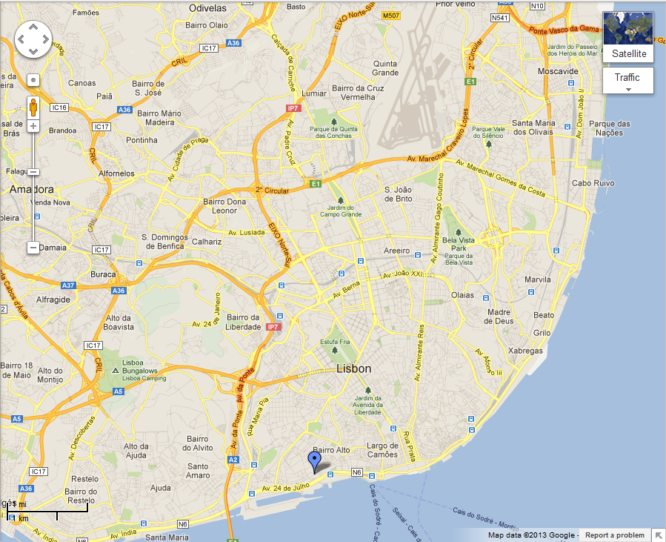

X Airport

X São Jorge Castle
Hotel
X Cais do Sodré

A pre-booking has been made at York House Hotel.

Please make the reservation yourself until February the 25th,
indicating the reference: PREPARE.

The agreed price per room and night is: 110 Euros

This includes: breakfast, meeting room with internet access and coffee breaks.

How to arrive from Lisbon Airport:
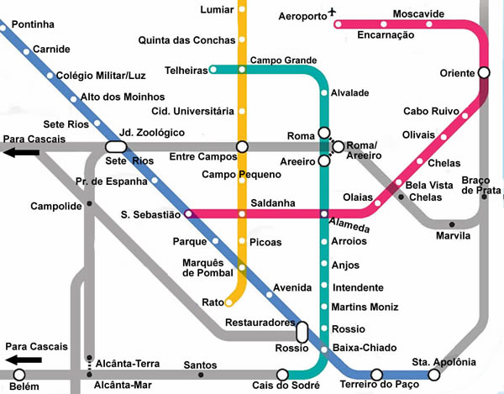
Finally Lisbon Airport has metro: red line to Alameda and then take the green line to Cais do Sodré. Or head for the Carris buses interface and take nr. 91 to Cais do Sodré, you should exit at the last stop. At Cais do Sodré you can take the train and leave at the first stop: Santos, or in alternative take the tram line nr. 15 and also get out at Santos. The York House Lisbon is around 5 minutes walking from both the train or tram line (1/4 mile). You should take Calçada Ribeiro Santos and then Janelas Verdes Street.
The York House Lisbon is located at 5 minutes walking (1/4 mile) from the train station Santos (Lisbon – Cascais train road), from the tram line or taxis.
Contacts:

PREPARE Secretariat
Pavel Ruzicka
Secretary General
E-mail: pavel.ruzicka@empress.cz

LNEG
Cristina Rocha and David Camocho
cristina.rocha@lneg.pt; david.camocho@lneg.pt

